**Automation on Scaled Server list, Duration, and its Cost through Autoscaling group.**

**Document Information and History:**

|  |  |  |  |  |  |  |  |
| --- | --- | --- | --- | --- | --- | --- | --- |
| **Version** | **Date** | **Author** | **Reviewer** | **Review Date** | **Approver** | **Approved Date** | **Description** |
| 0.1 |  | Yashwanth S | Vidya E |  | Vidya E |  | Initial Draft |

**Document Control Information:**

|  |  |  |  |  |  |  |
| --- | --- | --- | --- | --- | --- | --- |
| **Document Id** | **Document Owner** | **Document Approver** | **Document Custodian** | **Location** | **Retention** | **Disposition** |
| Idx_aws_Autoscaling_Cost | Idexcel Cloud Support team | ISC | Idexcel Cloud Support Team | Confluence | Till it becomes obselete | By deleting from confluence/Creating new version |

1. **Introduction**
   1. **Purpose**
   2. **Scope**
   3. **Audience**
2. **Overview**
   1. **Prerequisites**
   2. **GitHub Repository Details**
   3. **Functioning**
   4. **Steps to execute**
3. **Introduction**
   1. **Purpose**

The Purpose of this document is to fetch Scaled servers, duration of scaled servers and its Cost through Auto scaling group

**1.2 Scope**

Scope of this document includes procedure to be followed for execution the script file.

**1.3 Audience**

The primary audience for this document is the AWS team.

1. **Overview**

This script gives the output in .csv file which contains the servers which is scaled, its duration and cost of each scaled servers along with launch time and termination time

**2.1 Prerequisites:**

1. Packages to be installed before execution are Python 3.8 or any higher version, aws-cli/2.4.20 version and boto3.
2. To install boto3 use **pip install boto3** command.
3. Make sure that AWS programmatic credentials need to be configured in the system.
4. AWS account EC2 console read access permission is required for all the resources to execute this script.

**2.2 Github Repository Details:**

**Repo: aws-msp-automation**

**Branch: dev-infra-monitoring-automations**

**2.3 Functioning:**

1. Create clients after importing the necessary modules.
2. Read the Autoscaling group which we specify in the parameter
3. Will go through the Autoscaling group activities and fetch all the scaled servers, but we will specify in parameter from date and to date
4. Check for a match by iterating through the Autoscaling activities, using the given parameter will fetch the scaled servers in between the given date
5. Once the match is found it will be calculating the durations and will multiply it with the instance type cost
6. Create the output file with write mode, write the header and csv data frame into the csv file.

**2.4 Steps to execute:**

1. Make sure to update the credentials for the respective account before executing the steps and give the profile as **default** since we are establishing a boto3 connection. This is needed as the credentials get expired.

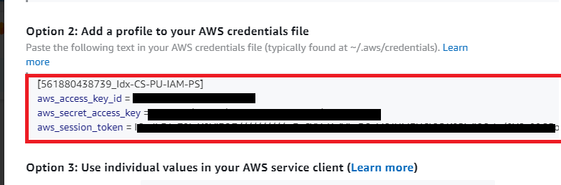

1. Before Execute the file in python run time environment go inside script and give the Autoscaling group name

1. When running the script, make sure to input the necessary details



1. E.g.: **python "Automation on Scaled Server list, Duration and its Cost through Autoscaling group.py**
2. "Once your python file has been executed, the output will be saved in the same location where the python file is located

1. The result needs to be checked in the .csv file

7. To delete empty rows in one shot,

* Select all the Data from column A, Row 1 to end of data

* After select, Go to **Find and select** in excel, click on **go to special**

* Select the Blanks and hit ok

* Once Blanks are selected, the empty rows will get selected, after that click on **delete the rows**

